INSTRUCTIONS FOR PREPARING AND SUBMITTING A
REQUEST FOR ADDITIONAL FUNDS (RAF)

The following document explains how Tribes and Bureau of Indian Affairs (BIA) agencies can prepare and submit a Request for Additional Funds (RAF) for welfare assistance. Submitting an RAF is optional and does not guarantee an increase in funding. If the program’s RAF is approved, the program’s funding will be adjusted to the requested amount, however it will be subject to pro rata distribution (if applicable).
The Financial Assistance and Social Services Report (FASSR) is only form required for a program to receive welfare assistance funding.
A RAF package includes two documents:
1. Request for Additional Funds Form
2. RAF Financial Assistance and Social Services Report (FASSR) with projected expenditures for the current year.
Each program must coordinate with its BIA Regional office, the Office of Self Governance (OSG) or the Office of Indian Services, Division of Workforce Development (OIS-DWD), here and after referred to as the respective program office, to submit a RAF. A RAF should be utilized when a program anticipates a potential shortfall in welfare assistance funds for the current operating year and wants to request additional welfare assistance funds. The RAF must demonstrate how the level of expenditures for the current funding year is expected to be greater than the program’s reported expenditures in the previous operating year.

Before submitting an RAF, the program should compare its actual expenditures from the previous year certified FASSR (column P) with its projected expenditures on the current year FASSR (column P). The RAF must include a minimum of four months supporting documentation of actual expenditures.

Fiscal Year (FY) programs, actual expenditures will be assessed from October to April. The projected expenditures will cover Quarters 3 (April-May-June) and Quarter 4 (July-August-September).
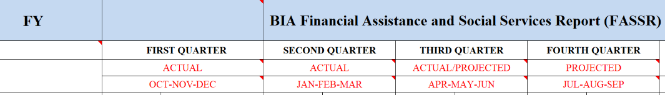

Calendar Year (CY) programs, actual expenditures will be assessed from January to April. The projected expenditures will be for Quarters 2 (May and June), Quarter 3 (July-August-September) and Quarter 4 (October-November-December).
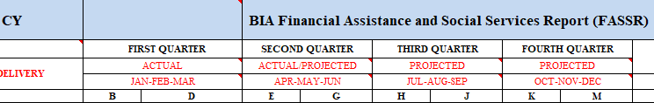

Programs are required to fill out the RAF form and must attach their current year RAF FASSR. The respective program will analyze the data to illustrate the potential impact on the program should additional welfare assistance funding not be allocated. The RAF narrative must provide comprehensive details justifying the request for additional funding. Although the RAF form and RAF FASSR are required, programs are encouraged to submit any additional supporting documentation to support the request.
Program RAF Submission – Due Dates
All program RAF submissions must be submitted to their respective offices by 5:00 pm EST on May 8, to ensure consideration. The respective office will evaluate and recommend approval of the program’s RAF.

The respective program office will submit a memorandum and RAF documents to form to the Office of Indian Services-Division of Human Services (OIS-DHS) at DHS_FASSR@bia.gov, no later than 5:00 pm EST on May 22. RAFs received after May 22, at 5:00pm EST will not be accepted or approved.

Request for Additional Funds (RAF) Form

Answer the following questions in detail and provide as much information as possible.

Name of Tribe:
Request for Additional Funding Amount | $
- Describe how program expenditures are expected to be greater in the current operating year, than as reported in the previous year FASSR. (Please use actual expenditure data and projected data to justify the narrative – the FASSR should reflect this).
- Describe the impact (programmatic-wise) if the requested funding is not approved. Specifically outline the number of individuals impacted and what the impact will be on those individuals. Be as detailed and specific as possible.
Print Name & Title
Signature | Date

